

Mini Project Report

of

**Database Systems Lab (CSE 2262)**

INVENTORY MANAGER API

Presented

BY

Rudra Patel : **210905324**

Section A : **52**

Department of Computer Science and Engineering

**Manipal Institute of Technology, Manipal.**

**April 2023**



DEPARTMENT OF COMPUTER SCIENCE & ENGINEERING

CERTIFICATE

This is to certify that the project titled **StockPile : A Comprehensive Inventory Management System** is a record of the bonafide work done by Rudra Patel (210905324) submitted in partial fulfilment of the requirements for the award of the Degree of Bachelor of Technology (B.Tech.) in COMPUTER SCIENCE & ENGINEERING of Manipal Institute of Technology, Manipal, Karnataka, (A Constituent Institute of Manipal Academy of Higher Education), during the academic year 2022-2023.

Name and Signature of Examiners:

1. Dr. Anup Bhat B., AssociateProfessor, CSE Dept

TABLE OF CONTENTS

ABSTRACT

**CHAPTER 1: INTRODUCTION**

**CHAPTER 2: PROBLEM STATEMENT & OBJECTIVES**

**CHAPTER 3: METHODOLOGY**

**CHAPTER 4: RESULTS & SNAPSHOTS**

**CHAPTER 5: CONCLUSION**

**CHATER 6: LIMITATIONS & FUTURE WORK**

**CHAPTER 7: REFERENCES**

**Introduction**

Stockpile is a database management system designed to provide an efficient and comprehensive solution for managing inventory. The system is implemented using POSTGRES and provides a relational database that allows users to store and retrieve information about inventory items, suppliers, customers, orders, and sales. The main goal of this project is to streamline the inventory management process by providing a user-friendly interface for managing inventory data, generating reports, and automating common inventory-related tasks. With the help of Stockpile, businesses can improve their inventory management efficiency, reduce costs, and boost profitability.

**Problem Statement and Objectives**

Inefficient inventory management can lead to increased costs and reduced profitability for businesses. Without a proper system in place, inventory data can be disorganized and difficult to manage.

The aim of this project is to provide a comprehensive inventory management system Stockpile, which automates inventory-related tasks, improves data accuracy, and enables businesses to make informed decisions about their inventory.

 Stockpile aims to have the following features:

* Inventory tracking: track all inventory items, including stock level and location.
* Automated inventory management: generate purchase orders and update stock levels automatically.
* Reporting and analytics: provide detailed reports and analytics on inventory levels, sales, and other metrics.
* Customer data tracking: track customer data, including purchase history and contact information.

**Methodology**

* The first step was to identify the constraints and requirements for this manager.
* Then we identified our entities such as Products, Suplier, Shop etc.
* After which we constructed the ER diagram.
* Using the ER diagram, we reduced it to a relational schema.

Assumptions:

* A product can belong to multiple storage units
* A storage unit can belong to multiple shops
* A shop can have multiple storage units linked to it.
* When ever a product is sold its taken from the storageunit linked to that shop with the most amout of that product.
* A suplier can only suply one product

**ER Diagram**:

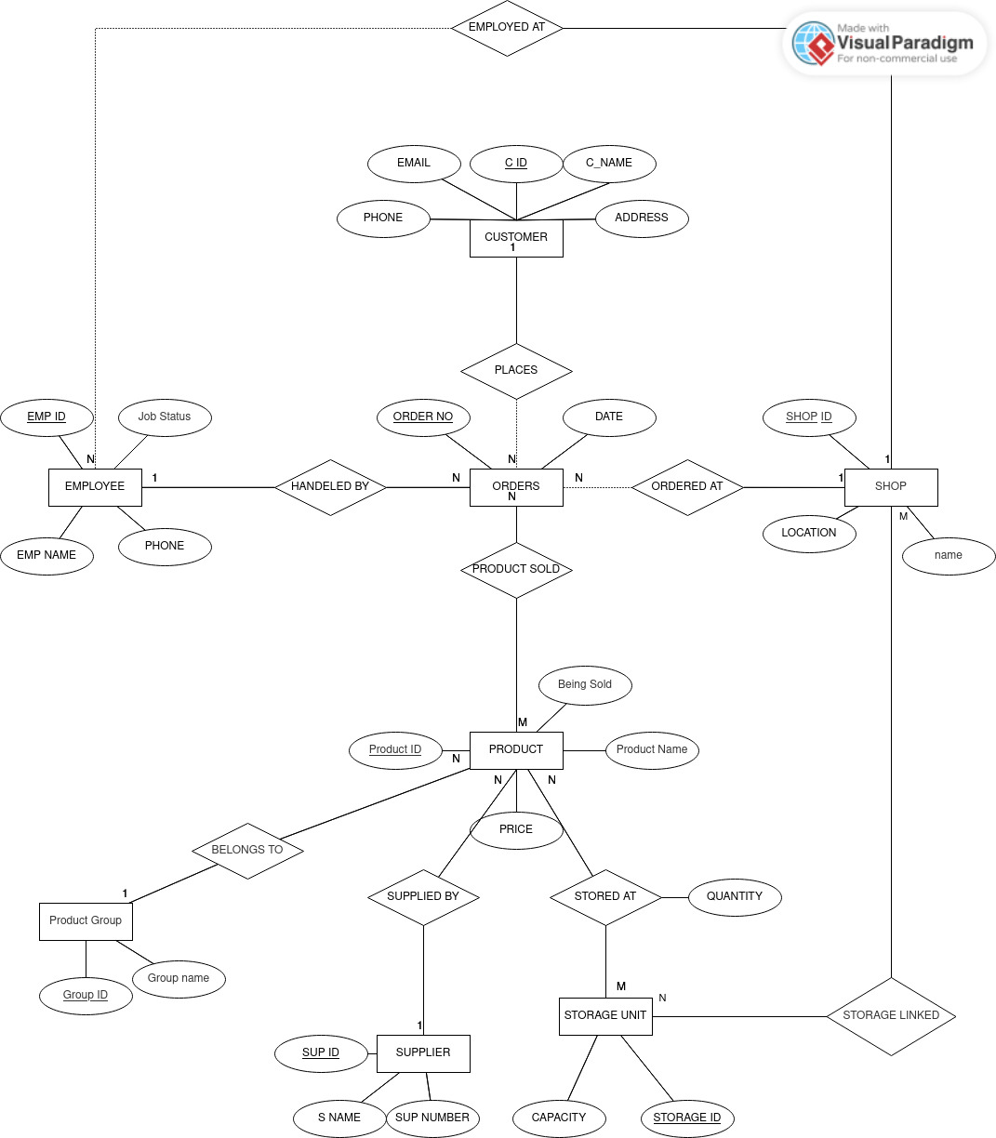

**ER to Relational Schema**

**Step1:** Identify strong entities.

**CUSTOMER** (CUSTOMER_ID, C_NAME, ADDRESS, PHONE, EMAIL)

**ORDERS** (ORDER_ID, CREATED_AT)

**EMPLOYEE** (EMPLOYEE_ID, EMPLOYEE_NAME, JOB_STATUS,PHONE)

**SHOP** (SHOP_ID, NAME, LOCATION)

**STORAGE UNIT** (STORAGE_ID, UNIT KEY, CAPACITY)

**PRODUCT** (PRODUCT_ID, NAME,BEING SOLD)

**PRODUCT GROUP** (GROUP_ID, GROUP NAME)

**Step2:** Identify weak entities.

**No weak entities.**

**Step3:** Identify relationships.

**STORAGELINKED** (SHOPID, STORAGEID)

**STOREDAT** (PRODUCTID, STORAGEID, QUANTITY)

**PRODUCTSOLD** (ORDERID, PRODUCTID, QUANTITY)

**Step4:** Merging relations with entities

**employee**(id,name,phone,created_at,jobStatus,branch_id)

**orders**(id,created_at,branch_id,customer_id,emp_id)

**products**(id,photo,name,price,created_at,productsBeingSold,groupId,supId)

**Normalization**

In the database used each table has a primary key, and all other columns in the table are functionally dependent on that primary key or dont have any dependencies at all. Therefore, each table is in Boyce-Codd Normal Form (BCNF), and normalization is not needed.

To be more specific:

* ProductsGroup table has a primary key (id), and name column is functionally dependent on that primary key.
* Suplier table has a primary key (id), and name and phone columns are functionally dependent on that primary key.
* Products table has a primary key (id), and all other columns (photo, group, name, price, supId, created_at, updated_at, and productBeingSold) are functionally dependent on that primary key.
* Shop table has a primary key (id), and name, location, created_at, and updated_at columns are functionally dependent on that primary key.
* Customer table has a primary key (id), and name, phone, address, email, and created_at columns are functionally dependent on that primary key.
* Employee table has a primary key (id), and name, phone, branchId, created_at, and jobStatus columns are functionally dependent on that primary key.
* Orders table has a primary key (id), and customerId, branchId, empId, and created_at columns are functionally dependent on that primary key.
* Invoice table has a primary key (id), and orderId, amount, and products columns are functionally dependent on that primary key.
* ProductSold table has a composite primary key (productId, orderId), and quantity and created_at columns are functionally dependent on that composite primary key.
* StorageUnit table has a primary key (id), and unitKey and capacity columns are functionally dependent on that primary key.
* StoredAt table has a composite primary key (productId, storageId), and quantity column is functionally dependent on that composite primary key.
* StorageLinked table has a composite primary key (storageId, ShopId), and no other columns are present.

Therefore, every table in this database is in BCNF.

**Relational Tables with sample data**

Customer:

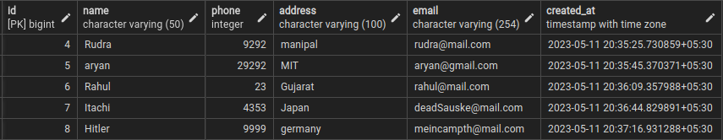

Employee:

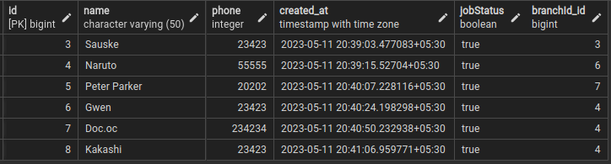

Invoices:

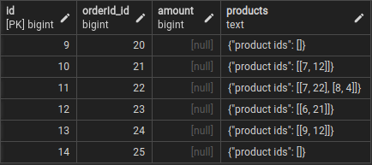

Orders:

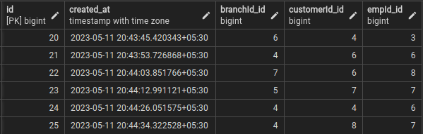

Products:

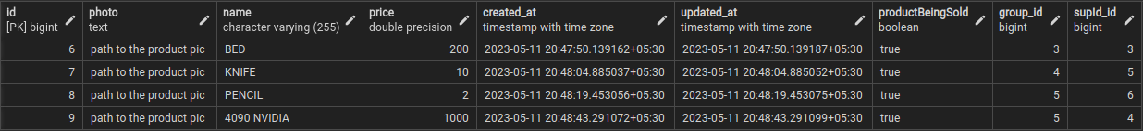

Product Group:

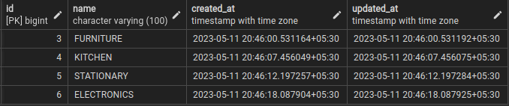

Products Sold:

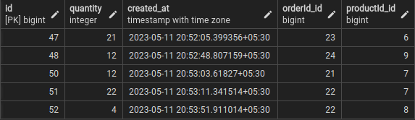

## Shop:

## 

## Storage Linked:

## 

## Stored At:

## 

## Supliers:

## 

UI :

ADMIN PAGE:

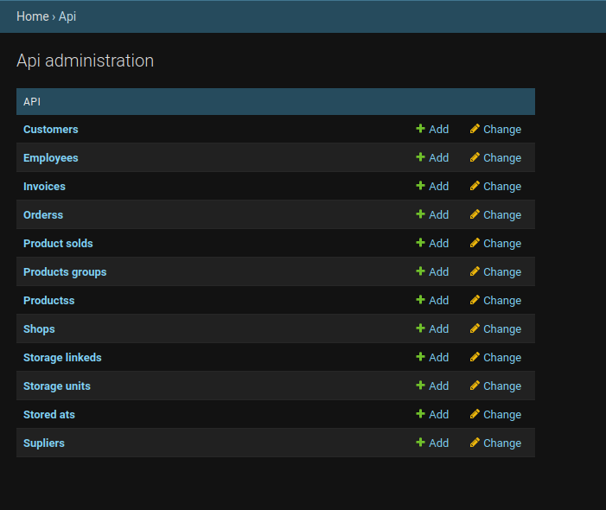

EMPLOYEE :

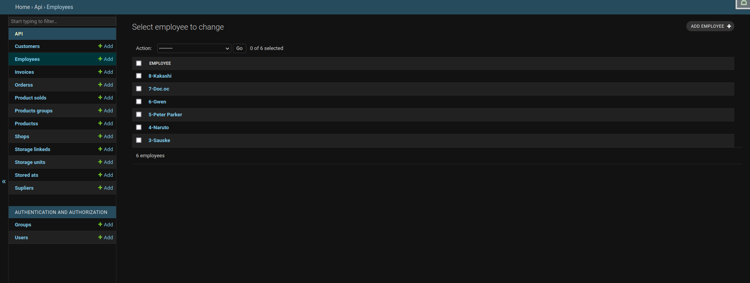

ORDERS :

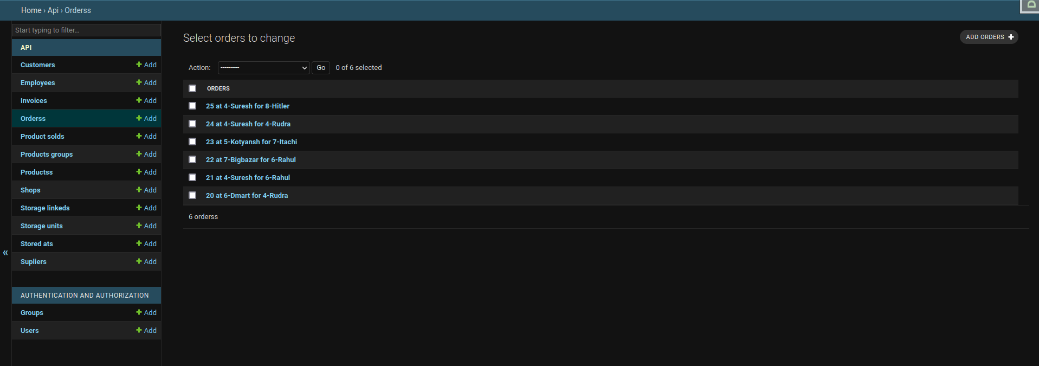

Products Sold :

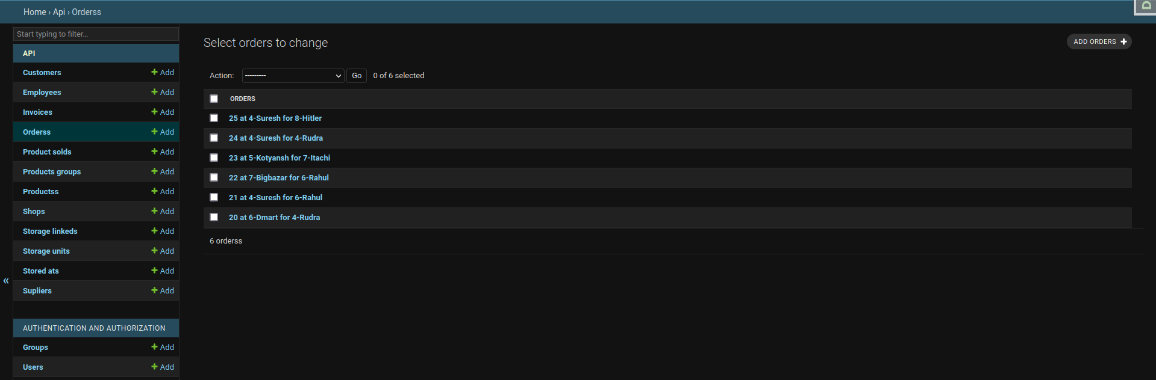

Adding Customer:

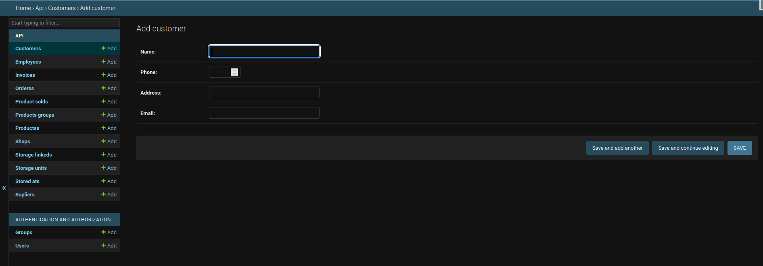

**DDL COMMANDS:**

CREATE TABLE IF NOT EXISTS public.api_customer

(

id bigint NOT NULL DEFAULT nextval('api_customer_id_seq'::regclass),

name character varying(50) COLLATE pg_catalog."default" NOT NULL,

phone integer NOT NULL,

address character varying(100) COLLATE pg_catalog."default" NOT NULL,

email character varying(254) COLLATE pg_catalog."default" NOT NULL,

created_at timestamp with time zone NOT NULL,

CONSTRAINT api_customer_pkey PRIMARY KEY (id),

CONSTRAINT api_customer_name_key UNIQUE (name),

CONSTRAINT api_customer_phone_check CHECK (phone >= 0)

)

CREATE TABLE IF NOT EXISTS public.api_employee

(

id bigint NOT NULL DEFAULT nextval('api_employee_id_seq'::regclass),

name character varying(50) COLLATE pg_catalog."default" NOT NULL,

phone integer NOT NULL,

created_at timestamp with time zone NOT NULL,

"jobStatus" boolean NOT NULL,

"branchId_id" bigint,

CONSTRAINT api_employee_pkey PRIMARY KEY (id),

CONSTRAINT api_employee_name_key UNIQUE (name),

CONSTRAINT "api_employee_branchId_id_487f0a03_fk" FOREIGN KEY ("branchId_id")

REFERENCES public.api_shop (id) MATCH SIMPLE

ON UPDATE NO ACTION

ON DELETE NO ACTION

DEFERRABLE INITIALLY DEFERRED,

CONSTRAINT api_employee_phone_check CHECK (phone >= 0)

)

CREATE TABLE IF NOT EXISTS public.api_invoice

(

id bigint NOT NULL DEFAULT nextval('api_invoice_id_seq'::regclass),

"orderId_id" bigint NOT NULL,

amount bigint,

products text COLLATE pg_catalog."default",

CONSTRAINT api_invoice_pkey PRIMARY KEY (id),

CONSTRAINT "api_invoice_orderId_id_43d1731f_fk_api_orders_id" FOREIGN KEY ("orderId_id")

REFERENCES public.api_orders (id) MATCH SIMPLE

ON UPDATE NO ACTION

ON DELETE NO ACTION

DEFERRABLE INITIALLY DEFERRED

)

CREATE TABLE IF NOT EXISTS public.api_orders

(

id bigint NOT NULL DEFAULT nextval('api_orders_id_seq'::regclass),

created_at timestamp with time zone NOT NULL,

"branchId_id" bigint,

"customerId_id" bigint,

"empId_id" bigint,

CONSTRAINT api_orders_pkey PRIMARY KEY (id),

CONSTRAINT "api_orders_branchId_id_6ce32572_fk" FOREIGN KEY ("branchId_id")

REFERENCES public.api_shop (id) MATCH SIMPLE

ON UPDATE NO ACTION

ON DELETE NO ACTION

DEFERRABLE INITIALLY DEFERRED,

CONSTRAINT "api_orders_customerId_id_e18f35aa_fk_api_customer_id" FOREIGN KEY ("customerId_id")

REFERENCES public.api_customer (id) MATCH SIMPLE

ON UPDATE NO ACTION

ON DELETE NO ACTION

DEFERRABLE INITIALLY DEFERRED,

CONSTRAINT "api_orders_empId_id_3c4bfbda_fk_api_employee_id" FOREIGN KEY ("empId_id")

REFERENCES public.api_employee (id) MATCH SIMPLE

ON UPDATE NO ACTION

ON DELETE NO ACTION

DEFERRABLE INITIALLY DEFERRED

)

CREATE TABLE IF NOT EXISTS public.api_products

(

id bigint NOT NULL DEFAULT nextval('api_products_id_seq'::regclass),

photo text COLLATE pg_catalog."default",

name character varying(255) COLLATE pg_catalog."default" NOT NULL,

price double precision NOT NULL,

created_at timestamp with time zone NOT NULL,

updated_at timestamp with time zone NOT NULL,

"productBeingSold" boolean NOT NULL,

group_id bigint,

"supId_id" bigint,

CONSTRAINT api_products_pkey PRIMARY KEY (id),

CONSTRAINT api_products_group_id_9afd0da8_fk_api_productsgroup_id FOREIGN KEY (group_id)

REFERENCES public.api_productsgroup (id) MATCH SIMPLE

ON UPDATE NO ACTION

ON DELETE NO ACTION

DEFERRABLE INITIALLY DEFERRED,

CONSTRAINT "api_products_supId_id_eb592123_fk_api_suplier_id" FOREIGN KEY ("supId_id")

REFERENCES public.api_suplier (id) MATCH SIMPLE

ON UPDATE NO ACTION

ON DELETE NO ACTION

DEFERRABLE INITIALLY DEFERRED

)

CREATE TABLE IF NOT EXISTS public.api_productsgroup

(

id bigint NOT NULL DEFAULT nextval('api_productsgroup_id_seq'::regclass),

name character varying(100) COLLATE pg_catalog."default" NOT NULL,

created_at timestamp with time zone NOT NULL,

updated_at timestamp with time zone NOT NULL,

CONSTRAINT api_productsgroup_pkey PRIMARY KEY (id),

CONSTRAINT api_productsgroup_name_key UNIQUE (name)

)

CREATE TABLE IF NOT EXISTS public.api_productsold

(

id bigint NOT NULL DEFAULT nextval('api_productsold_id_seq'::regclass),

quantity integer NOT NULL,

created_at timestamp with time zone NOT NULL,

"orderId_id" bigint NOT NULL,

"productId_id" bigint NOT NULL,

CONSTRAINT api_productsold_pkey PRIMARY KEY (id),

CONSTRAINT "api_productsold_productId_id_orderId_id_cfa75181_uniq" UNIQUE ("productId_id", "orderId_id"),

CONSTRAINT "api_productsold_orderId_id_7368b26a_fk_api_orders_id" FOREIGN KEY ("orderId_id")

REFERENCES public.api_orders (id) MATCH SIMPLE

ON UPDATE NO ACTION

ON DELETE NO ACTION

DEFERRABLE INITIALLY DEFERRED,

CONSTRAINT "api_productsold_productId_id_adc34ff7_fk_api_products_id" FOREIGN KEY ("productId_id")

REFERENCES public.api_products (id) MATCH SIMPLE

ON UPDATE NO ACTION

ON DELETE NO ACTION

DEFERRABLE INITIALLY DEFERRED,

CONSTRAINT api_productsold_quantity_check CHECK (quantity >= 0)

)

CREATE TABLE IF NOT EXISTS public.api_shop

(

id bigint NOT NULL DEFAULT nextval('api_shop_id_seq'::regclass),

name character varying(50) COLLATE pg_catalog."default" NOT NULL,

location character varying(50) COLLATE pg_catalog."default" NOT NULL,

created_at timestamp with time zone NOT NULL,

updated_at timestamp with time zone NOT NULL,

CONSTRAINT api_shop_pkey PRIMARY KEY (id),

CONSTRAINT api_shop_name_05fa0f8b_uniq UNIQUE (name)

)

CREATE TABLE IF NOT EXISTS public.api_storagelinked

(

id bigint NOT NULL DEFAULT nextval('api_storagelinked_id_seq'::regclass),

"ShopId_id" bigint NOT NULL,

"storageId_id" bigint NOT NULL,

CONSTRAINT api_storagelinked_pkey PRIMARY KEY (id),

CONSTRAINT "api_storagelinked_storageId_id_ShopId_id_e6c8950b_uniq" UNIQUE ("storageId_id", "ShopId_id"),

CONSTRAINT "api_storagelinked_ShopId_id_bc1ef242_fk" FOREIGN KEY ("ShopId_id")

REFERENCES public.api_shop (id) MATCH SIMPLE

ON UPDATE NO ACTION

ON DELETE NO ACTION

DEFERRABLE INITIALLY DEFERRED,

CONSTRAINT "api_storagelinked_storageId_id_bb77b01e_fk_api_storageunit_id" FOREIGN KEY ("storageId_id")

REFERENCES public.api_storageunit (id) MATCH SIMPLE

ON UPDATE NO ACTION

ON DELETE NO ACTION

DEFERRABLE INITIALLY DEFERRED

)

CREATE TABLE IF NOT EXISTS public.api_storageunit

(

id bigint NOT NULL DEFAULT nextval('api_storageunit_id_seq'::regclass),

capacity integer NOT NULL,

"unitKey" character varying(50) COLLATE pg_catalog."default" NOT NULL,

CONSTRAINT api_storageunit_pkey PRIMARY KEY (id),

CONSTRAINT "api_storageunit_unitKey_7f75ff50_uniq" UNIQUE ("unitKey"),

CONSTRAINT api_storageunit_capacity_check CHECK (capacity >= 0)

)

CREATE TABLE IF NOT EXISTS public.api_storedat

(

id bigint NOT NULL DEFAULT nextval('api_storedat_id_seq'::regclass),

quantity integer NOT NULL,

"productId_id" bigint NOT NULL,

"storageId_id" bigint NOT NULL,

CONSTRAINT api_storedat_pkey PRIMARY KEY (id),

CONSTRAINT "api_storedat_productId_id_storageId_id_39d34b6b_uniq" UNIQUE ("productId_id", "storageId_id"),

CONSTRAINT "api_storedat_productId_id_ae824ca8_fk_api_products_id" FOREIGN KEY ("productId_id")

REFERENCES public.api_products (id) MATCH SIMPLE

ON UPDATE NO ACTION

ON DELETE NO ACTION

DEFERRABLE INITIALLY DEFERRED,

CONSTRAINT "api_storedat_storageId_id_ed78eb1c_fk_api_storageunit_id" FOREIGN KEY ("storageId_id")

REFERENCES public.api_storageunit (id) MATCH SIMPLE

ON UPDATE NO ACTION

ON DELETE NO ACTION

DEFERRABLE INITIALLY DEFERRED,

CONSTRAINT api_storedat_quantity_check CHECK (quantity >= 0)

)

CREATE TABLE IF NOT EXISTS public.api_suplier

(

id bigint NOT NULL DEFAULT nextval('api_suplier_id_seq'::regclass),

name character varying(50) COLLATE pg_catalog."default" NOT NULL,

phone integer NOT NULL,

created_at timestamp with time zone NOT NULL,

updated_at timestamp with time zone NOT NULL,

CONSTRAINT api_suplier_pkey PRIMARY KEY (id),

CONSTRAINT api_suplier_name_key UNIQUE (name),

CONSTRAINT api_suplier_phone_check CHECK (phone >= 0)

)

SQL QUERIES :

1. createProductSold:

INSERT INTO "api_productsold" ("name", "jobStatus", "phone", "branchId")

VALUES ('value_of_name', 'value_of_jobStatus', 'value_of_phone', 'value_of_branchId');

1. getProductSolds:

sql

SELECT "api_productsold"."id", "api_productsold"."name", "api_productsold"."jobStatus", "api_productsold"."phone", "api_productsold"."branchId", "api_productsold"."created_at"

FROM "api_productsold";

1. getProductSold:

sql

SELECT "api_productsold"."id", "api_productsold"."name", "api_productsold"."jobStatus", "api_productsold"."phone", "api_productsold"."branchId", "api_productsold"."created_at"

FROM "api_productsold"

WHERE "api_productsold"."id" = pk;

1. updateProductSold:

sql

UPDATE "api_productsold"

SET

"name" = 'value_of_name',

"jobStatus" = 'value_of_jobStatus',

"phone" = 'value_of_phone',

"branchId" = 'value_of_branchId'

WHERE "api_productsold"."id" = pk;

1. deleteProductSold:

sql

DELETE FROM "api_productsold" WHERE "api_productsold"."id" = pk;

SAME BASIC QUERY FOR EACH TABLE

**COMPLEX SQL QUERIES :**

**PRODUCT SOLD BY ALL EMPLOYEES DURING A DURATION**

'SELECT "api_productsold"."id", "api_productsold"."productId_id", "api_productsold"."orderId_id", "api_productsold"."quantity", "api_productsold"."created_at" FROM "api_productsold"

**PRODUCT SOLD BY A SPECIFIC EMPLOYEES DURING A DURATION**

'SELECT "ps"."id", "ps"."productId_id", "ps"."orderId_id", "ps"."quantity", "ps"."created_at" FROM "api_orders" "o" JOIN "api_productsold" "ps" ON "o"."id" = "ps"."orderId_id" WHERE "o"."empId_id" = %s AND "o"."created_at" BETWEEN %s AND %s'

**GET SPACE LEFT IN A PARTICULAR STORAGE UNIT**

SELECT ("su"."capacity" - COALESCE(SUM("sd"."quantity"), 0)) AS "space_left"

FROM "api_storageunit" "su"

LEFT JOIN "api_storedat" "sd" ON "su"."id" = "sd"."storageId_id"

WHERE "su"."id" = %s

GROUP BY "su"."id", "su"."capacity"

**GET PRODUCTS WHOSE QUANTITY IS BELOW A CERTAIN THRESHOLD IN A ALL OR A SPECIFIC STORAGE UNIT**

'SELECT "api_products"."id", "api_products"."name", "api_storedat"."quantity" FROM "api_storedat" INNER JOIN "api_products" ON ("api_storedat"."productId_id" = "api_products"."id") WHERE "api_storedat"."quantity" < %s'

**GET PRODUCTS LINKED TO A STORAGE UNIT**

SELECT "p"."id", "p"."name","s"."quantity"

FROM "api_products" "p"

INNER JOIN "api_storedat" "s" ON "p"."id" = "s"."productId_id"

WHERE "s"."storageId_id" = %s;

**GET STORAGE UNIT USED MY MOST SHOPS**

SELECT "storageId_id","api_storageunit"."unitKey", COUNT(*) AS "num_shops"

FROM "api_storagelinked"

INNER JOIN "api_storageunit" ON ("api_storageunit"."id" = "api_storagelinked"."storageId_id")

GROUP BY "storageId_id","api_storageunit"."unitKey"

ORDER BY "num_shops" DESC

**GET CUSTOMERS WHO BOUGHT A SPECIFIC PRODUCT**

SELECT "name"

FROM "api_products"

WHERE %s IN (

SELECT "productId_id"

FROM "api_productsold"

WHERE "orderId_id" IN (

SELECT "id"

FROM "api_orders"

WHERE "api_orders"."created_at" BETWEEN NOW() - INTERVAL '1 WEEK' AND NOW()

)

);

**GET THE NUMBER OF A SPECIFIC PRODUCT LEFT THROUGH OUT ALL STORAGE UNITS**

SELECT "api_products"."name",SUM("quantity") as total_quantity

FROM "api_storedat"

INNER JOIN "api_products" on ("api_storedat"."productId_id" = "api_products"."id")

WHERE "productId_id" = %s

GROUP BY "api_products"."name"

**GET ALL THE PRODUCTS LINKED TO A PARTICULAR ORDER**

SELECT "api_products"."name", "api_productsold"."quantity"

FROM "api_productsold"

INNER JOIN "api_products" ON "api_productsold"."productId_id" = "api_products"."id"

WHERE "api_productsold"."orderId_id" = %s;

**GET EMPLOYEE WHO HAS CONDUCTED THE MOST SALES**

SELECT "emp"."id", "emp"."name", "emp"."phone", COUNT(*) as "sales"

FROM "api_employee" "emp"

JOIN "api_orders" "o" ON "o"."empId_id" = emp."id"

GROUP BY "emp"."id", "emp"."name", "emp"."phone"

ORDER BY "sales" DESC

LIMIT 1

**GET ALL STORAGE UNITS LINKED TO A PARTICULAR SHOP**

SELECT "su"."id", "su"."unitKey"

FROM "api_storageunit" "su"

INNER JOIN "api_storagelinked" "sd" ON "sd"."id" = "su"."id"

WHERE "sd"."ShopId_id" = %s

**GET TOTAL REVENUE GENERATED BY A SHOP IN A PER MONTH BASIS**

SELECT

TO_CHAR(DATE_TRUNC('month', "api_orders"."created_at"), 'YYYY-MM') AS month,

"api_orders"."branchId_id" AS shop_id,

SUM("api_products"."price" * "api_productsold"."quantity") AS revenue

FROM "api_orders"

INNER JOIN "api_productsold"

ON "api_orders"."id" = "api_productsold"."orderId_id"

INNER JOIN "api_products"

ON "api_productsold"."productId_id" = "api_products"."id"

GROUP BY

month, shop_id;

**GET SHOP WHICH HAS MOST ORDERS DURING A DURATION**

SELECT "branchId_id" as "shop_id", COUNT(*) AS "order_count"

FROM "api_orders" WHERE

"created_at" BETWEEN %s AND %s

GROUP BY "branchId_id"

ORDER BY "order_count" DESC

LIMIT 1;

**GET ALL EMPLOYEES WORKING AT A SHOP**

SELECT "e"."name", "e"."phone", "e"."jobStatus"

FROM "api_employee" AS "e"

INNER JOIN "api_shop" AS "s" ON "e"."branchId_id" = "s"."id"

WHERE "s"."id" = %s;

**GET ALL THE PRODUCTS AVAILABLE AT A SHOP**

SELECT "api_products"."id", "api_products"."name", "api_productsold"."quantity"

FROM "api_products"

INNER JOIN (

SELECT "api_storedat"."productId_id", SUM("api_storedat"."quantity") AS "quantity"

FROM "api_storedat"

INNER JOIN "api_storageunit" ON "api_storedat"."storageId_id" = "api_storageunit"."id"

INNER JOIN "api_shop" ON "api_storageunit"."id" = "api_shop"."id"

INNER JOIN "api_storagelinked" ON "api_storageunit"."id" = "api_storagelinked"."storageId_id"

WHERE "api_shop"."id" = %s

GROUP BY "api_storedat"."productId_id"

) AS "api_productsold" ON "api_products"."id" = "api_productsold"."productId_id"

**GET AVG NUMBERS OF ORDERS PER MONTH**

SELECT

AVG(num_orders) AS avg_orders_per_month

FROM (

SELECT

DATE_TRUNC('month', "api_orders"."created_at") AS month,

COUNT(*) AS num_orders

FROM "api_orders"

WHERE "api_orders"."branchId_id" = %s

GROUP BY month

) AS orders_per_month;

**GET AVG REVENUE PER MONTH FROM A SHOP**

SELECT

AVG(revenue_per_month) AS avg_revenue_per_month

FROM (

SELECT

TO_CHAR("api_orders"."created_at", 'YYYY-MM') AS year_month,

"api_orders"."branchId_id" AS shop_id,

SUM("api_products"."price" * "api_productsold"."quantity") AS revenue_per_month

FROM "api_orders"

INNER JOIN "api_productsold"

ON "api_orders"."id" = "api_productsold"."orderId_id"

INNER JOIN "api_products"

ON "api_productsold"."productId_id" = "api_products"."id"

WHERE "api_orders"."branchId_id" = %s

GROUP BY year_month, shop_id

) AS revenue_per_month_by_shop;

**GET ALL ORDERS DONE BY A CUSTOMER**

SELECT "o"."id","cus"."name", o."amount", "o"."created_at" FROM "api_orders" "o" INNER JOIN "api_customer" "cus" ON ("o"."customerId_id" = "cus"."id") WHERE "o"."customerId_id" = %s

**SOME QUERIES TO GET STATS OF THE INVENTORIES**

sales_query = """

SELECT "api_shop"."location" AS store_location, SUM("api_orders"."amount") AS total_sales

FROM "api_orders"

INNER JOIN "api_shop" ON "api_orders"."branchId_id" = "api_shop"."id"

GROUP BY "api_shop"."location"

ORDER BY total_sales DESC;

"""

quantity_query = """

SELECT "api_shop"."location" AS store_location, SUM("api_storedat"."quantity") AS total_quantity

FROM "api_storedat"

INNER JOIN "api_storageunit" ON "api_storedat"."storageId_id" = "api_storageunit"."id"

INNER JOIN "api_storagelinked" ON "api_storageunit"."id" = "api_storagelinked"."storageId_id"

INNER JOIN "api_shop" ON "api_storagelinked"."ShopId_id" = "api_shop"."id"

GROUP BY "api_shop"."location"

ORDER BY total_quantity DESC;

"""

orders_query = """

SELECT EXTRACT(YEAR FROM "api_orders"."created_at") AS order_year, COUNT(*) AS total_orders

FROM "api_orders"

GROUP BY order_year

ORDER BY order_year ASC;

"""

product_query = """

SELECT "api_products"."name" AS product_name, SUM("api_productsold"."quantity") AS total_sold

FROM "api_productsold"

INNER JOIN "api_products" ON "api_productsold"."productId_id" = "api_products"."id"

GROUP BY "api_products"."name"

ORDER BY total_sold DESC;

"""

**GET MOST POPULAR GROUP IN A DURATION OR OVERALL**

SELECT "api_productsgroup"."id", "api_productsgroup"."name", SUM("api_productsold"."quantity") AS "total_quantity"

FROM "api_productsgroup"

INNER JOIN "api_products" ON ("api_productsgroup"."id" = "api_products"."group_id")

INNER JOIN "api_productsold" ON ("api_products"."id" = "api_productsold"."productId_id")

WHERE "api_products"."productBeingSold" = TRUE AND "api_productsold"."created_at" BETWEEN %s AND %s

GROUP BY "api_productsgroup"."id"

ORDER BY "total_quantity" DESC

LIMIT 1;

PL/SQL

-- Function and Cursor

**A PL/SQL function block that takes in customer id as input and outputs the most ordered product group of the customer:**

CREATE OR REPLACE FUNCTION get_most_ordered_group(customer_id bigint) RETURN NUMBER IS

DECLARE

group_key bigint;

BEGIN

SELECT p.group_id into group_key

FROM api_orders o

INNER JOIN "api_productsold" "ps" ON (o.id = "ps"."orderId_id")

INNER JOIN "api_products" "p" ON "ps"."productId_id" = "p"."id"

WHERE "o"."customerId_id" = customer_id

GROUP BY p.group_id,p.name

ORDER BY sum(quantity) DESC

FETCH FIRST 1 ROW ONLY;

RETURN group_key;

END;

**A PL/SQL function block that takes in a refcursor as input and returns a ref cursor with the most ordered groups of every customer**

CREATE OR REPLACE FUNCTION get_most_ordered_group_for_all(ref1 refcursor) RETURNS refcursor IS

DECLARE

BEGIN

OPEN ref1 FOR

SELECT c.id, c.name, get_most_ordered_group(c.id)

FROM api_customer c;

return NEXT ref1;

END;

**A PL/SQL function block that takes in a refcursor as input and returns a ref cursor with the most ordered product of every customer**

CREATE OR REPLACE FUNCTION get_most_ordered_product(ref1 refcursor) RETURNS refcursor IS

BEGIN

OPEN ref1 FOR

SELECT c.id, c.name, get_most_ordered_products(c.id)

FROM api_customer c;

return NEXT ref1;

END;

**A PL/SQL function block that takes in customer id as input and outputs the most ordered product group of the customer:**

CREATE OR REPLACE FUNCTION get_most_ordered_product_for_all(customer_id bigint) RETURN NUMBER IS

DECLARE

product_name bigint;

BEGIN

SELECT p.id

INTO product_name

FROM api_orders o

INNER JOIN "api_productsold" "ps" ON (o.id = "ps"."orderId_id")

INNER JOIN "api_products" "p" ON "ps"."productId_id" = "p"."id"

WHERE "o"."customerId_id" = customer_id

GROUP BY "p"."id", "p"."name"

ORDER BY sum(quantity) DESC

FETCH FIRST 1 ROW ONLY;

RETURN product_name;

END;

**A PL/SQL function block that takes in Storage unit id and returns the space left**

CREATE OR REPLACE FUNCTION get_space_left(unit_id bigint) RETURNS bigint IS  
DECLARE

space_left bigint;

BEGIN

SELECT ("su"."capacity" - COALESCE(SUM("sd"."quantity"), 0)) into space_left

FROM "api_storageunit" "su"

LEFT JOIN "api_storedat" "sd" ON "su"."id" = "sd"."storageId_id"

WHERE "su"."id" = unit_id

GROUP BY "su"."id", "su"."capacity";

RETURN space_left;

END;

**A PL/SQL function block that takes in Storage unit id and returns the space left**

CREATE OR REPLACE FUNCTION get_storage_unit_from_shop_with_highest_quantity(shop_id bigint,product_id bigint) RETURNS bigint IS

DECLARE

storage_unit_id bigint;

max_quantity bigint := 0;

current_quantity bigint;

max_storage_id bigint := 1;

BEGIN

FOR storage_unit_id IN

SELECT "storageId_id"

FROM api_storagelinked

WHERE "ShopId_id" = shop_id

LOOP

SELECT quantity INTO current_quantity

FROM api_storedat

WHERE "storageId_id" = storage_unit_id AND "productId_id" = product_id;

IF current_quantity > max_quantity THEN

max_quantity := current_quantity;

max_storage_id := storage_unit_id;

END IF;

END LOOP;

RETURN max_storage_id;

END;

**A PL/SQL function block that takes in Shop id and returns all the storage units linked with it**

CREATE OR REPLACE FUNCTION get_storage_units_for_shop(shop_id bigint,ref1 refcursor) RETURNS refcursor IS

BEGIN

OPEN ref1 FOR

SELECT s.id

FROM api_storageunit s

INNER JOIN api_storagelinked sl ON s.id = sl."storageId_id"

WHERE sl."ShopId_id" = shop_id;

RETURN NEXT ref1;

END;

-- Trigger:

**On entering a tuple in storedat table it checks if there is enough space left in the unit to contain the incoming products**

CREATE OR REPLACE TRIGGER check_space_left  
AFTER INSERT ON storedat  
FOR EACH ROW  
BEGIN

IF NEW.quantity > get_space_left(NEW."storageId_id") THEN

RAISE EXCEPTION 'Not enough space available in storage unit';

END IF;

RETURN NEW;

END;

**On entering a tuple in storedat table it checks if there is enough space left in the unit to contain the incoming products**

CREATE OR REPLACE TRIGGER check_space_left  
AFTER INSERT ON storedat  
FOR EACH ROW  
BEGIN

IF NEW.quantity > get_space_left(NEW."storageId_id") THEN

RAISE EXCEPTION 'Not enough space available in storage unit';

END IF;

RETURN NEW;

END;

**On entering a tuple in productsold it subtracts the respective quantity from the storage unit linked to the particular order if multiple units have the same products the one with greater quantity will be selected**

DECLARE

shop_id INTEGER;

storage_unit_id INTEGER;

product_id INTEGER;

quantity_out INTEGER;

BEGIN

SELECT "o"."branchId_id", "ps"."productId_id", "ps"."quantity"

INTO shop_id, product_id, quantity_out

FROM "api_productsold" "ps"

INNER JOIN "api_orders" "o" ON "ps"."orderId_id" = "o"."id"

WHERE "ps"."id" = NEW."id";

SELECT get_storage_unit_from_shop_with_highest_quantity(shop_id, NEW."productId_id") INTO storage_unit_id;

IF storage_unit_id IS NULL THEN

RAISE EXCEPTION 'No storage units found for product % in shop %', NEW."productId_id", shop_id;

END IF;

UPDATE "api_storedat"

SET "quantity" = "quantity" - quantity_out

WHERE "storageId_id" = storage_unit_id AND "productId_id" = product_id;

RETURN NEW;

END;

**On entering a tuple in storedat table it updates the invoice related to that specific order to have the correct total cost and also add all the products linked to the specific order in a array for reference**

DECLARE

invoice_id INTEGER;

product_price NUMERIC;

BEGIN

-- get the invoice id for the current order

SELECT id INTO invoice_id FROM api_invoice WHERE "orderId_id" = NEW."orderId_id";

-- get the price of the product

SELECT price INTO product_price FROM api_products WHERE id = NEW."productId_id";

-- update the invoice with the new amount

UPDATE api_invoice

SET amount = amount + NEW.quantity * product_price,

products = jsonb_set(products::jsonb, '{product ids}',

(products::jsonb->>'product ids')::jsonb ||

jsonb_build_array(jsonb_build_array(NEW."productId_id", NEW.quantity)))

WHERE id = invoice_id;

RETURN NEW;

END;